## **Introduction**

The idea under consideration is more of an opportunity than a solution to a problem. The idea is to provide a digital platform that will be made up of multiple digital apps, like a web app and a mobile app. This will be the same app with multiple interfaces on the web as well as on the mobile. The need to implement these multiple interfaces is to better facilitate the user's ability to easily use the platform on the go. These digital platforms will be facilitating users divided into two main groups with different needs and requirements.

The first type of user is the ride-hailing service providers for long tours to different tourist spots across different geographical locations. The second type of user is a ride-hailing consumer that will be booking the service providers to go for visiting the tourist spots.

It is a type of extension to the already existing idea of ride-hailing services. The currently existing ride-hailing services are mostly limited to short travels both in time and distance as they are within the limits of a city. You hire a ride-hailing service provider from some platform for a very short span and time to mainly move from one part of the city to the other. The other thing about this currently implemented model is that the variety and range of vehicles that people can use to provide services are limited. Our platform will also compete with already existing players in the field and will lead in this new dimension as a first mover, taking full advantage and capturing most of the market that will be created in this new domain.

Our idea will target or will be dependent on two major industries. These industries are the automotive industry and the tourism industry. Both of these industries are on the rise and creating more and more opportunities for people to grab on to. We will be supporting this argument and our idea with different datasets. We will be showing different analyses, visualizations, and projections from these datasets to further strengthen our stance, our estimations, and our proposals. In this document, we will be doing a business analysis of this idea using the CRISP-DM methodology.

**Group Members' Contributions and Work Distribution**

This being a group project is a result of the collective effort of all the members of the group, which is mentioned above at the start. The project was thoroughly discussed and analyzed by all the group members. The project was planned and the workload was evenly distributed among the group members. We worked with concrete coordination and shared proper feedback throughout our work on the project to ensure that we were all are on the same page and are equally contributing.

**Business Understanding**

In reference to what was explained earlier in the introduction section, the business model that we are proposing here and will try to implement is to extend and capture an already existing and very well-implemented idea by different companies and startups. Different ride-hailing services are booming across the globe with tremendous success and huge gains in existing market capture and inclusion of new untouched sectors into the market. These services have raised the market cap to new heights.

Our idea is an extension to the existing ones as explained earlier and also aims at the same targets and that too on new highs. Our idea is to target the same existing user base with lucrative schemes and more attractive and fruitful services for both types of the users of our services. In addition to this, we also aim to capture the new user base from a different and broad perspective and thus increasing the market base. We will be more successful in this new dimension by making full advantage of being the first movers in this unexplored field.

We will be providing the existing and new customers a new alternative to the existing ride-hailing services bringing in more competition and quality to the services. The new and main addition that our platform will provide is taking this same model to a new high by providing the same services to the tourism industry. We will take the same services currently being provided by existing platforms to the level of tourism. The service providers can plan and publish their availability of services to the users. The service providers can come on our platform and search for these published service providers. They can plan their journeys by filtering based on different filters, getting the best deals for them at the best time that suits them the most.

The first mandatory deliverable that must be implemented to run the basic end-to-end business will include a mobile app and a web app. Both these apps will allow the following:

* Register the User
* Make an availability plan for the service
* Publish the above plan
* Search different plans
* Filter among different plans depending on different criteria
* Hire service provider after filtering and selecting one

The initial release with all necessary modules and functionalities can be released in a time span of 6 months after going through the complete research, design, and development lifecycle. The team required to achieve this milestone in the given time will be between 12-20 members. These members will be from different departments involved in the process like designers, architects, developers, and researchers.

The IT world is evolving continuously at a very rapid pace. To keep up with this pace is very critical for success. A good idea is not the only ingredient for the recipe to succeed. But a good well executed and implemented at the right time is definitely a key to success. So missing the right time and deadline will have an impact on the proposed and estimated costs of the project and will definitely affect the profits ultimately.

As explained earlier how crucial is time management and meeting the deadlines to the project's success. So we have to be very cautious and have a detailed thought before selecting the tools and technologies for the project. Keeping all of this in mind we would like to go with the MERN stack. Using this stack will keep us in both frontend and backend all in javascript and we can go for React Native to develop the mobile app which is a lot similar to that of ReactJs. This will bring consistency to all of our stack. This move will enable us to rotate our resources and make better use of resources depending on the need of the hour. The project will kick off with the research phase which will include different feasibility plans and an analysis of other key components that may affect our project. This will be followed by the design phase where the architecture of the product will be defined. This phase will eventually lead to the actual development of the product. The development phase is both accompanied and followed by the testing of the product which will ensure that a quality product meeting all the best quality standards is launched in the market.

### **Data Understanding**

The dataset acquired for this cross industrials data mining technique are taken from various sources such as

* The Society of Irish Motor Industry (SIMI)
* Ireland Open Data Portal

**Motor Industry Dataset**

The motor industry datasets were gathered through the extensive datasets provided by The Society of Irish Motor Industry [reference] in its National Vehicle Statistics from year 2012 to 2019. The dataset initially contained statistics related to different category of vehicles which also included the private cars category which we have considered for our analysis. The dataset contains the total number of cars sold by each manufacturer in a year.

**Tourism Industry Dataset**

The dataset of tourism industry was gathered from the Ireland’s open data portal of government. The dataset “TMQ05 - Tourism and Travel Estimated Earnings and Expenditure” was published by Central Statistics Office and contains 8 columns and 97 rows.

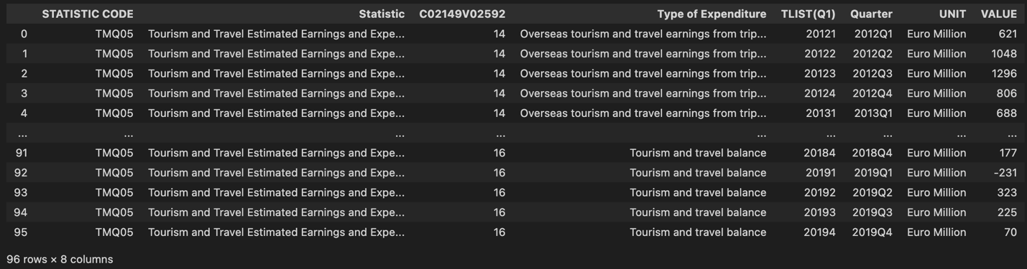

The dataset columns along with their metadata are given as follows.

|  |  |  |
| --- | --- | --- |
| **Column Name** | **Column Type** | **Column Description** |
| STATISTIC CODE | Object | Contains a unique code for this statistic file. |
| Statistic | Object | Statistics displayed in the file. |
| C02149V02592 | Int64 | Category code. |
| Type of Expenditure | Object | Categorical variable with 'Overseas tourism and travel earnings from trips to Ireland', 'Overseas tourism and travel expenditure by Irish residents abroad', 'Tourism and travel balance' as the categories. |
| TLIST(Q1) | Int64 | Year and quarter in integer format. |
| Quarter | Object | Year and quarter in string format. |
| UNIT | Object | The unit in which the revenue is calculated (Euro Million) |
| VALUE | Int64 | The revenue which is generated from the tourism category. |

Some statistics related to this dataset are also given below.

* Dataset has zero null entries.
* Dataset has zero duplicate entries.

The histogram of the dataset is also given as follows. The revenue generated from tourism is somewhat uniform with a slightly left skewed irregular behavior. Whereas the years are evenly distributed.

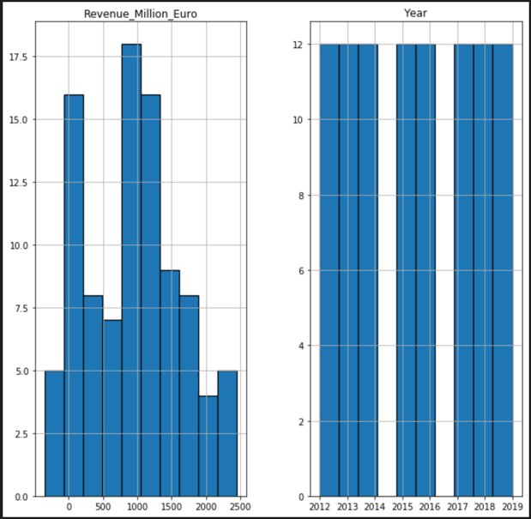

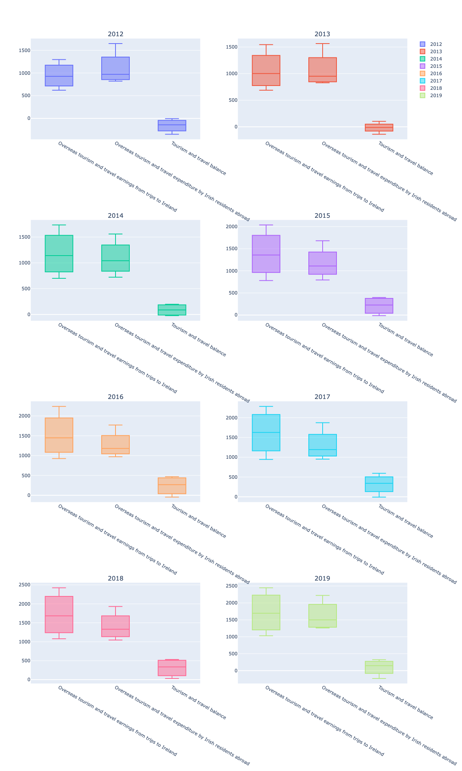

Here we also do the outlier analysis by plotting the categorical data with numerical data in the form of boxplots. Given above is the boxplot which shows us the revenue generated by foreigners by coming to Ireland for the tourism purposes and we can clearly see that the revenue generated by foreign tourism has been growing in comparison to the money spent by irish people who go to other countries for the tourism. It is a clear indicator that tourism industry has been boosting over the time and if given proper attention it could generate billions of euros.

This can also be seen through the graph which is given below. Here we can also see that the tourism revenue deficit which was created due to the fact the tourism was not as much prevalent in the earlier years as compared to the later years leading to 2019 where that deficit has turned to positive. This suggests an overall revenue surplus in monetary terms.

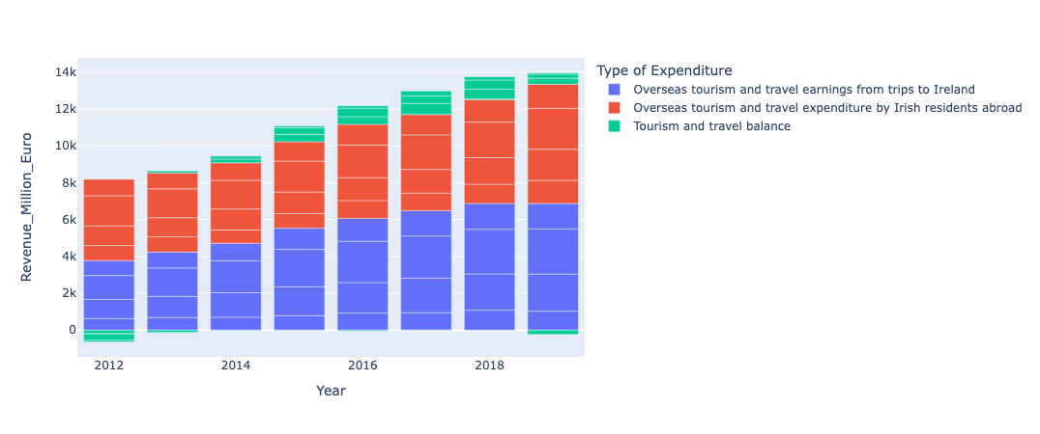

Now in the graph below we analyze the quarterly behavior of the revenue generated. We see that most of the tourism related revenue is generated in the 3rd quarter of the year in the months of July, August and September. It can be attributed to the fact that the weather in these months is very good.

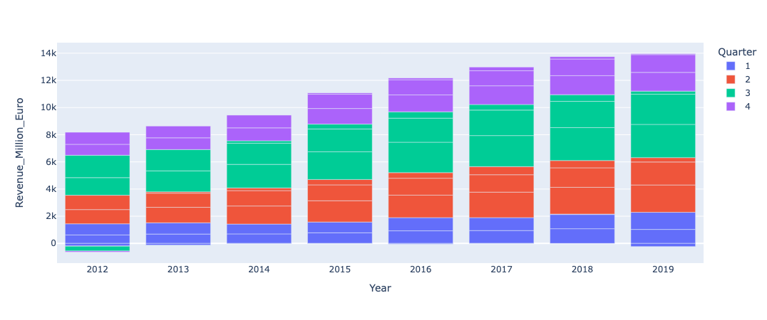

The detailed boxplot of this behavior year wise can also be seen below.

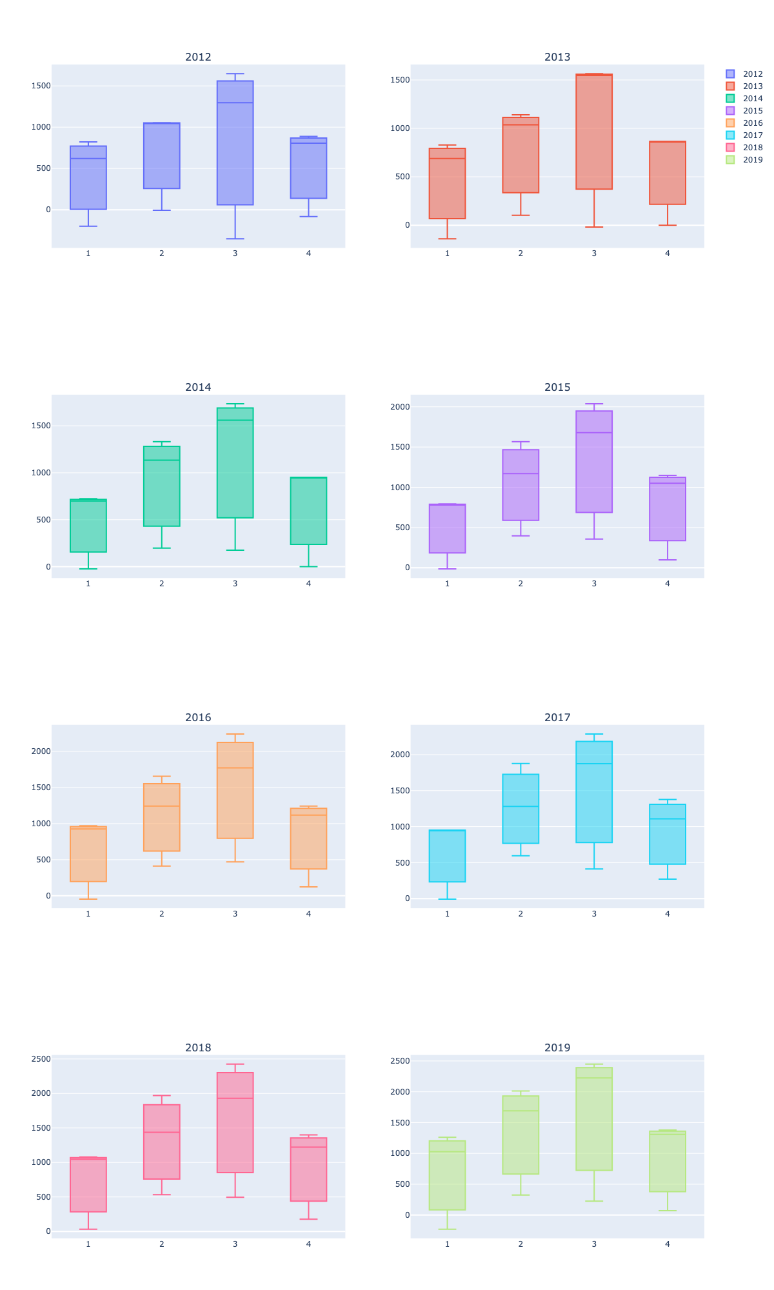

Whereas the yearly aggregated tourism revenue (Overseas tourism and travel earnings from trips to Ireland) is also projected in the following graph. This shows a steady climb over the years suggesting that the tourism sector has been generating more and more revenue over the years.

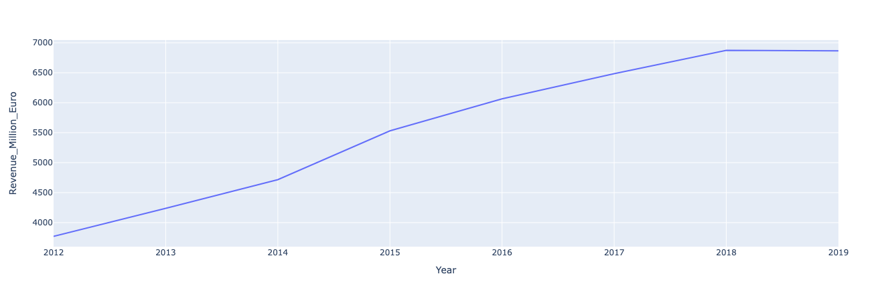

### **Data Preparation**

### **Modeling**